**DAILY ONLINE ACTIVITIES SUMMARY**

|  |  |  |  |  |
| --- | --- | --- | --- | --- |
| **Date:** | 11/07/2020 | **Name:** | JASLINE SHARON TAURO | |
| **Sem & Sec** | 4th sem,  A Section | **USN:** | 4AL18CS029 | |
| **Online Test Summary** | | | | |
| **Subject** | N/A | | | |
| **Max. Marks** | N/A | **Score** | N/A | |
| **Certification Course Summary** | | | | |
| **Course** | **Salesforce Mobile App Customization** | | | |
| **Certificate Provider** | Sales Force | **Duration:** | | 3 hrs |
| **Coding Challenges** | | | | |
| **Problem Statement:**  Write a Java program for Reversal algorithm for array rotation by 3. | | | | |
| **Status:** | | Executed | | |
| **Uploaded the report in GitHub** | | YES | | |
| **If yes Repository name** | | <https://github.com/jaslinesharontauro/JAVA_Prgms> | | |
| **Uploaded the report in slack** | | YES | | |

**Certification Course Details:**

# Today I started the new course “ **Salesforce Mobile App Customization**” by Sales Force. Today I learnt about how to **Create Global Quick Actions and to Create Object-Specific Quick Actions**.

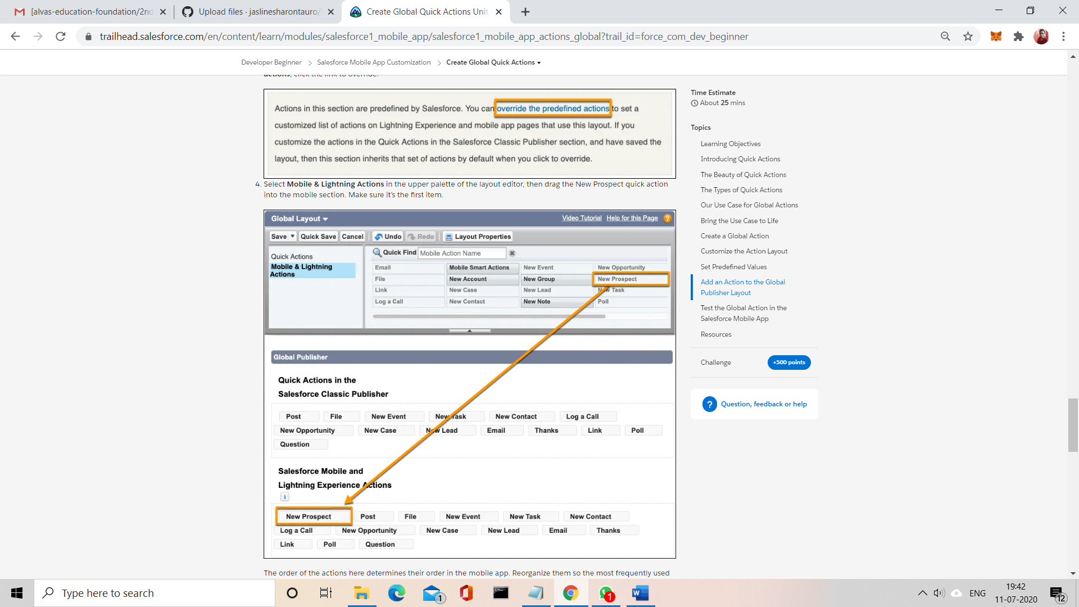

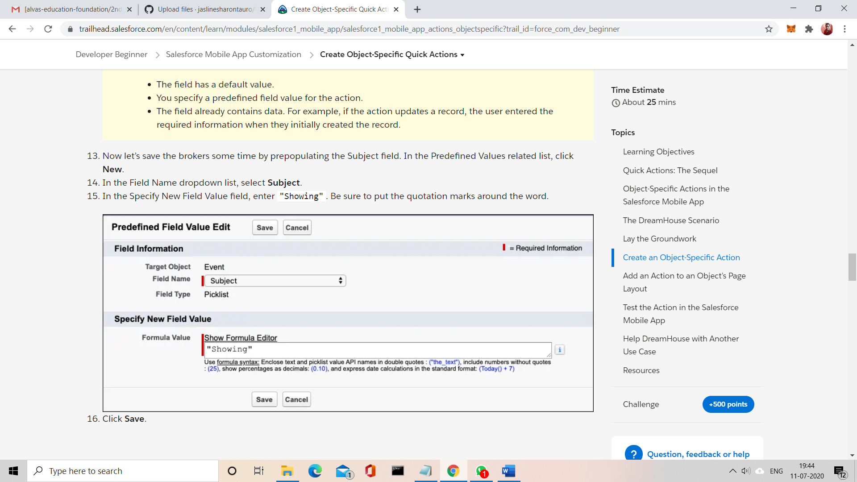

CODING CHALLENGES:

Problem Statement:

Write a Java program for Reversal algorithm for array rotation by 3.

Given an array a[], array size n and d the number of index to be rotated task is to write a function rotate(arr[],d,n) that rotates arr[] of size n by d elements.

Example  
Input:  
n= 6  
arr []= {1,2,3,4,5,6}  
d=3 (specific)  
Output: arr[]= {4,5,6,1,2,3}

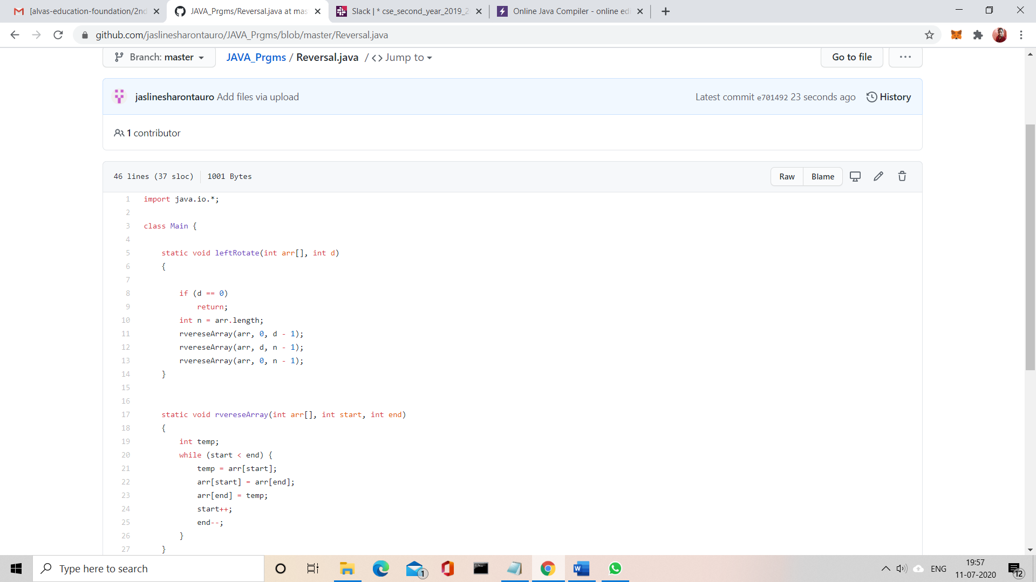

Solution uploaded in GitHub